Geometry: Unit 10, Lesson 9
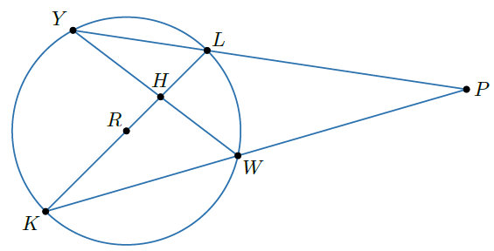
- Circle $R$ is shown with points $Y$, $L$, $W$, and $K$ on the circle. Point $H$ is inside the circle and point $P$ is outside the circle. What equation can be used to find the measure of $\hat{YK}$?

$$\frac{m\hat{YK}+m\hat{LW}}{2}=m∠YHK$$
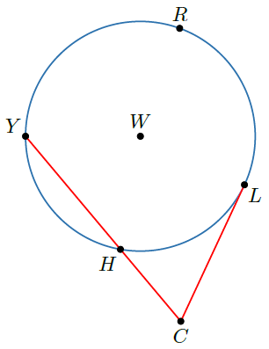

- Circle $W$ is shown with points $Y$, $H$, $L$, and $R$ on the circle and point $C$ outside the circle. $∠LCH$ is formed by the intersection of segments $\overline{LC}$ and $\overline{YC}$ which meet outside the circle at point $C$. $m\hat{YRL}=210°$ and $m\hat{HL}=65°$. What is half the difference of $m\hat{YRL}$ and $m\hat{HL}$?

$$72.5°$$
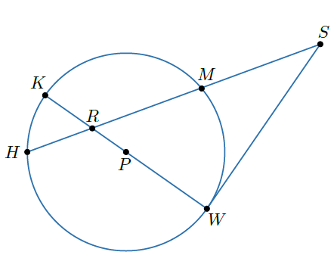
- Circle $P$ is shown with points $K$, $H$, $W$, and $M$ on the circle. Point $R$ is inside the circle and point $S$ is outside the circle. What is a secant of circle $P$?

$$\overline{SH}$$

